**Milestone 3 Report**

Authors: Kian Frassek, Cameron Clark and Thiyashan Pillay

Table of Contents

Table of figures and tables: 3

Common Blocks: 3

Schematic of board with labels 3

Key of the wire colours: 3

Key for LEDs: 4

Picture of board 4

# Table of figures and tables:

Figure 1: Vero board Layout with labels 3

Figure 2: Picture of Veroboard (on top) 4

Figure 3: Picture of Veroboard (on bottom) 4

Figure 4: Simulink Block Diagram of the Code Flashed to the Arduino 5

Figure 5: The internals of the chart 5

Table 1: Key for wires 3

Table 2: Key for LED's 4

# Common Blocks:

DIY layout creator was used to draw all circuit diagrams shown below.

# Schematic of board with labels

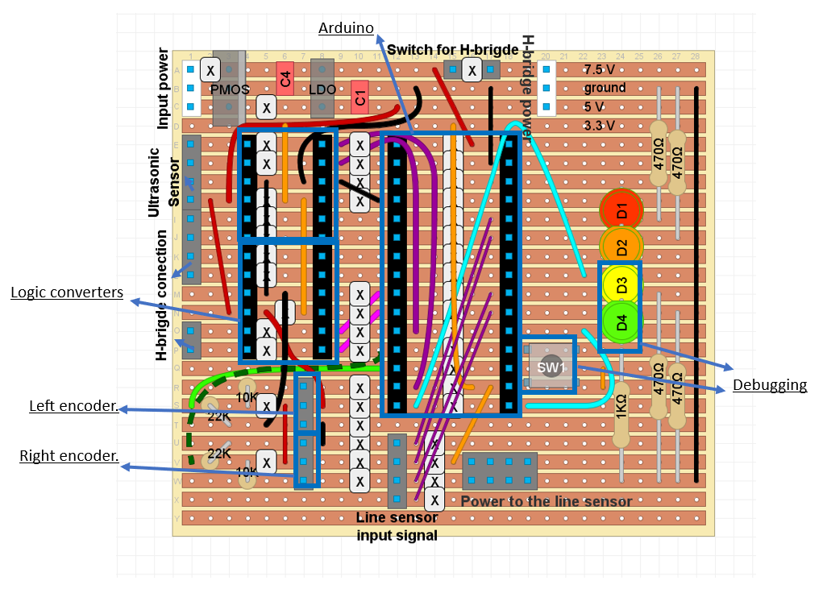

Figure : Vero board Layout with labels

## Key of the wire colours:

Table : Key for wires

|  |  |  |  |
| --- | --- | --- | --- |
|  | | Light blue | Arduino to LED |
|  | | purple | Arduino to Line sensor and Ultrasonic logic level converters |
|  | | pink | Arduino to H-Bridge logic level converters |
|  |  | Green (light and dark) | Arduino to Rotary encoders |
|  | | Black | Ground |
|  | | Dark red | 5V Power |
|  | | Orange | 3V3 Power |

## Key for LEDs:

Table : Key for LED's

|  |
| --- |
| Exploring the Maze: |
| * Yellow indicates when ultrasonic is active, * Green indicates when an object is within 15cm of the robot. |
| Driving back to Closest Object: |
| * Indicates how many intersections it needs to pass before coming to a stop. * This is done as a 2 bit binary number where Yellow is the MSB |

# Picture of board

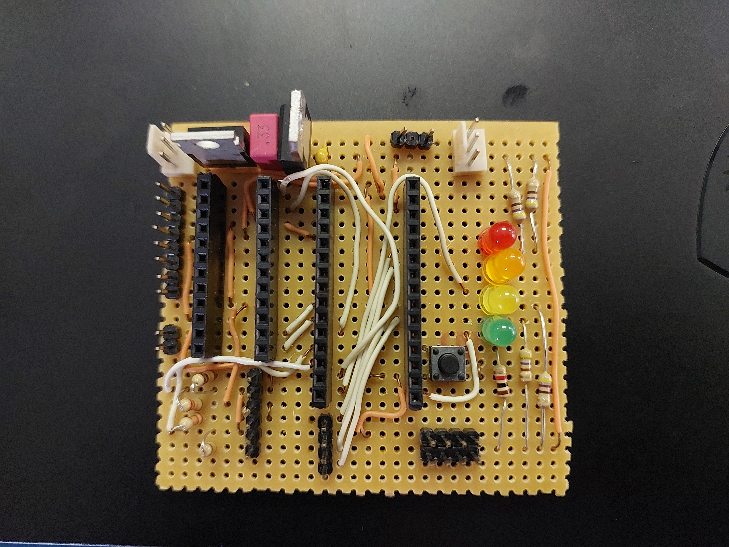

Figure : Picture of Veroboard (on top)

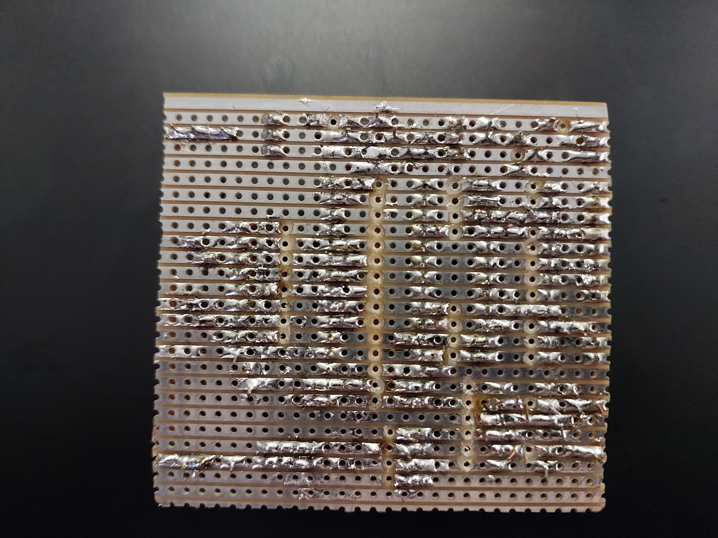

Figure : Picture of Veroboard (on bottom)

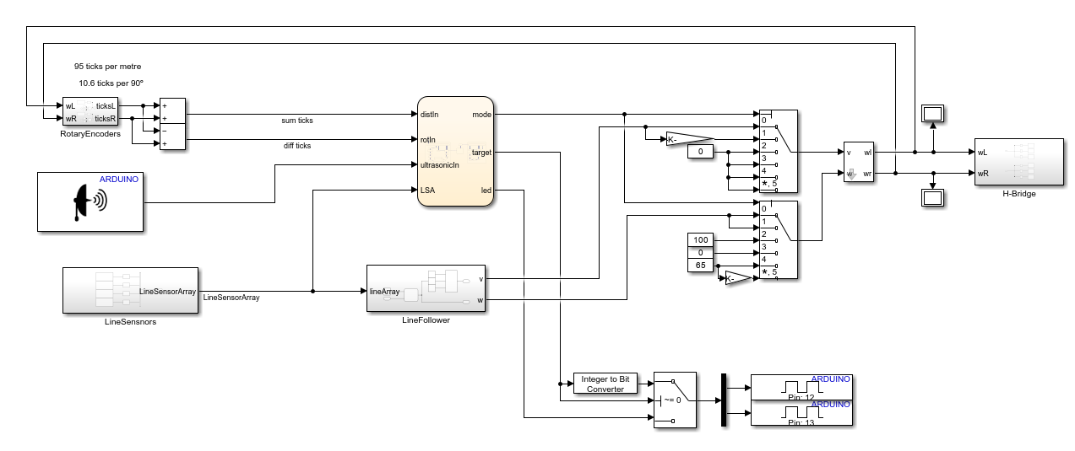

Figure : Simulink Block Diagram of the Code Flashed to the Arduino

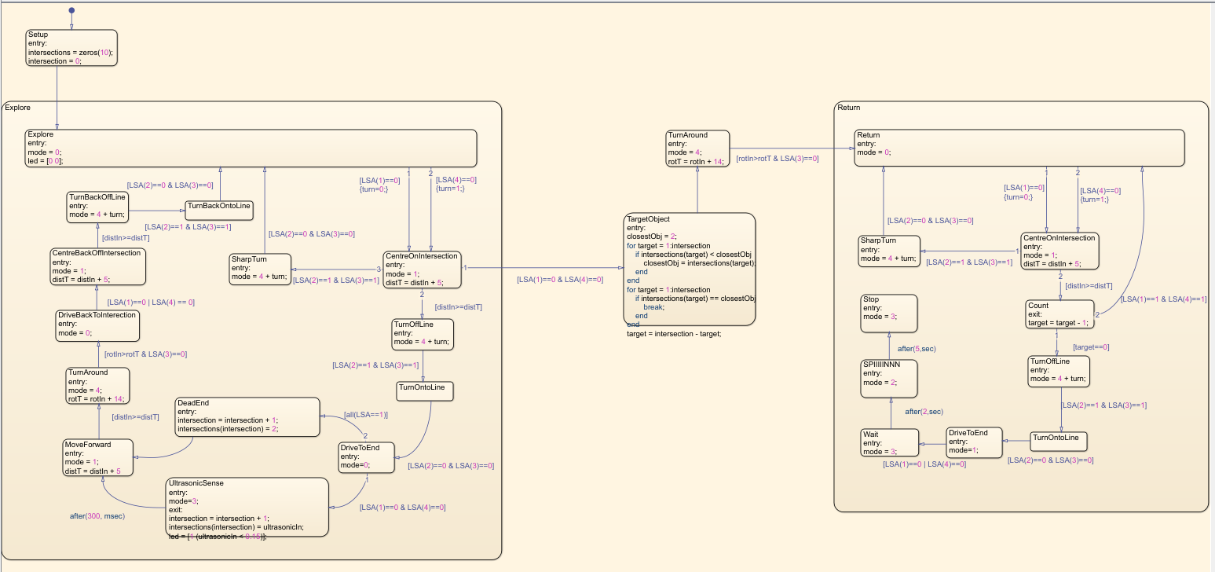

Figure : The internals of the chart

The name of the Simulink diagram in the .zip folder is $LinearCompetitiveModel$. It is a Simulink file.